Mandala and John DeMarco
Reading Assignment
Level 2

Mandalas
Pythagoras described geometry as visual music. Music is created by applying laws of frequency and sound in certain ways. States of harmonic resonance are produced when frequencies are combined in ways that are in unison with universal law.
These same laws can be applied to produce visual harmony. Instead of frequency and sound it is angle and shape that are combined in ways that are in unison with universal law. Geometric shapes can be orchestrated in ways to produce visual symphonies that show the harmonic unification of diversity.
Mandalas translate complex mathematical expressions into simple shapes and forms. They show how the basic patterns governing the evolution of life workout the most beautiful results.
The word mandala arises from the Sanskrit and means sacred circle. The circle symbolizes the womb of creation; and mandalas are geometric designs that are made through uniform divisions of the circle. The shapes that are formed from these divisions are symbols that embody the mathematical principles found throughout creation. They reveal the inner workings of nature and the inherent order of the universe.
Mandalas act as a bridge between the higher and lower realms. They are interdimensional gateways linking human consciousness to the realms of archetypes and the infinite. The relationship of form, movement, space and time is evoked by the mandala.
Mandalas offer a way to engage with the inherent harmony and balance of nature. They bring the principles of nature into our field of awareness. For thousands of years, mandala imagery has served as a means to an expanded way of thinking. The images transcend language and the rational mind. They bring about a certain wisdom of universal knowledge and a deeper understanding of human consciousness.

Yantras
Yantras are a particular field of mandala imagery that visually represent the harmonic tones of mantras (sacred sounds). By directing our thought patterns to these archetypal planes we invite the essence of these levels to penetrate our minds and thinking. An attunement of individual consciousness with the harmony of universal consciousness develops.
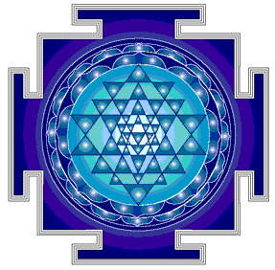
Sri Yantra - or Yantra of Creation - is the most revered of all the Hindu yantras. There is a mysterious beauty that arises in the way that nine diverse triangles interlink to form a state of perfect balance and harmony, and the complementation of the yin and yang ~ creating 43 smaller triangles that define the Sri Yantra.
The Sri Yantra is believed to be the image of the OM mantra, which in the Hindu tradition is understood to be the primordial sound of creation. In his book Rhythms of Vision, Lawrence Blair writes that when the OM is correctly intoned into a tonoscope (a device that transforms sound into a visual representation on a screen), it first produces a circle. As the tone is completed, the circle is filled sequentially with concentric squares, triangles and finally, as the last traces of the "mmm" have died away, the Sri Yantra.
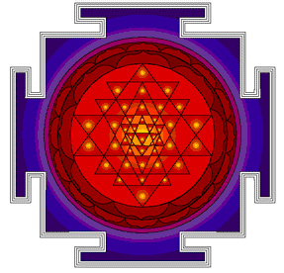
Sri Yantra Eternal Fire: Primes the kundalini. For the serious soul intent on burning through karma and the obstructions to one's spiritual growth. The spiritual warrior.
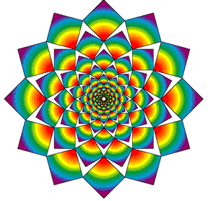
Whirling Squares: In sacred geometry the circle symbolizes the spiritual plane and the square symbolizes the material, physical plane. The whirling squares yantra design portrays the union of spirit and matter. It simultaneously expresses the spiritualization of matter and the cloaking of spirit.

The Golden Ratio
The golden ratio, or it's mathematical term the phi ratio is a mathematical principle that pervades the universe. This principle can be found from molecules (including the dna molecule) to spiral galaxies. It is a universal relationship that exists between two elements of an equation in a natural situation.
In sacred geometry the golden ratio can be expressed in numbers, lengths, shapes and forms, which include golden proportioned triangles, rectangles and spirals. The golden ratio is the golden thread that links all levels of creation. If the emotion of love is the pervading principle of the universe, the golden ratio is the mathematical equation of it.
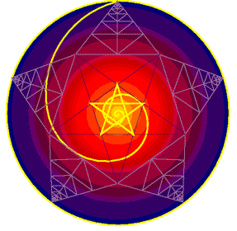
The golden ratio is also present in the Sri Yantra. Pentagram star with radiating spiral. Awakening and metamorphisis. New beginnings. A link to the universal heart. A key to realms of higher awareness. Pentagram star rainbow with yin and yang spirals forming universal heart. A nuturing and enriching connection with universal abundance and empathy.
The designs above are part of a collection of sacred geometric artwork by Jonathan Quintin, P.O. Box 1621 Solana Beach, CA 92075

Introduction to John DeMarco,

Featured Artist for the Mandala Acrylic Painting Project
John DeMarco was born in Philadelphia, PA in 1958. His interest in painting started at the age of thirteen, and he went on to become a three-year art major at Central High School. After high school, he attended the Philadelphia College of Art for a short period, but dropped out in order to pursue studies on his own.
He is also a musician, writes fiction, non-fiction and poetry, and has an ongoing interest in spiritual awareness, body-mind connection, and human evolution.
Since leaving Philadelphia in 1986, he has lived in Southern and Central California, Northern New Mexico, Maui, Western North Carolina, and Kaua'i. He currently resides in Southern Oregon. DeMarco has shown his work in galleries throughout the US, owned and operated the Altarworks Gallery in Taos, New Mexico, from 1993-94, functioned as co-artistic director for a professional dance school in Los Angeles. He ran the "bricks and mortar" Circle2000 Gallery on Kaua'i until deciding to close its doors late last year and display his works on the internet instead. De Marco explains that “among the benefits of a virtual gallery are that it's open 24 hours a day, it's available worldwide, and I don't have to sweep the floors. The major drawback is that it simply isn't the same as seeing the work in person.” The mission of his website is to promote his own art and the art and ideas of those whom he feels embody a sense of evolutionary direction in their work.
His mission as an artist is to “present a contemporary vision or visual sense of the sublime that is inherent in our own existence.” He attempts this through the use of geometric patterning, organic abstraction, and occasionally through the use of realistic imagery, often combining these elements to simulate unique inner atmospheres. For him, art is a way of developing intimacy with the creative power of the universe, much like that of traditional spiritual practice, especially the yogic forms of the East. At the same time, however, he sees artistic expression to be very material and down to earth. It is this paradox of joining and reconciling the spiritual with the terrestrial that intrigues him most about being an artist. His primary interest at present is to build a body of work that will help bridge the gap between traditional geometric and symbolic sacred art and the broader and more intellectualized realm of contemporary art. There is a distinct place, he feels, where they merge, and it is from this place that he feels the contemporary viewer can begin to firmly understand the sacred qualities of all forms of creative expression. DeMarco believes art to be at its most beautiful and profound when it serves to reconcile the polarities of life, and is also able to remind us of how amazing it is simply to be human. In other words, when it draws our awareness to a common center within and awakens the heart.
He utilizes three distinct yet interrelated styles in his work: geometric (angular forms), organic (free-form, curvy shapes) and representational (life-like). It is the interplay of these styles that conceptually and visually distinguishes what he does. He likes to combine and integrate these three styles due to the fact that the brain constantly works with these same three forms of visual language on both subtle and concrete levels in order to perceive reality. By combining geometric, organic and representational form, he feels he is working with a perceptual language that stimulates the brain more as a whole.
DeMarco was terrible at math in high school and spent most of his time in the art department. He immediately recognized the need to brush up on his geometry skills when he began drawing mandalas in 1987. He works mostly with at straight edge and compass, but sometimes uses a calculator for unusual divisions. He also uses French curves and his own templates for making arcs and maintaining symmetry. John’s definition of a mandala is below:
Mandalas are universal and have been employed by virtually every culture on the planet. Their roots are prehistoric and they have been used traditionally as tools for meditation and trance, as well as for passing on esoteric knowledge which would be encoded in the geometry and symbols employed. Where language failed to convey the mysteries of the universe, the open-ended geometric world of the mandala served to educate and inspire. It is like a key to deeper significance set in color- and number-relations, angles and lines.
DeMarco’s oil paintings are created using a modified Renaissance glazing technique that allows for maximum depth and durability. The finest oil colors are used along with a specially formulated medium of mastic, beeswax, stand oil and alkyd gel. The result is a richly glazed, layered surface. He paints on canvas, linen, and plastered or gessoed board. His works on paper are usually mixed dry/wet media compositions using different combinations of watercolor, gouache, charcoal, metal leaf, pastel, soluble pencil, graphite, and dry pigment. They are less layered and often much more geometric than the oils. He frequently works with handmade papers because of the rich and sensual variance of texture they provide.
DeMarco uses a variety of techniques for the application of paint to the surface, and is continually experimenting to find more. He combines wet and dry brushing, uses sponges and stipplers and various other means for creating textures, and sometimes works with a technique in which he lets paint bleed through a sheet of rice paper onto the painting surface underneath. He often uses an atomizer for spraying and spattering, and occasionally uses an airbrush, but only with water media.
DeMarco considers himself a contemporary artist, but he also leaves himself available for the possibility of accepting commissions for special installations such as altarpieces, or works specifically designed for meditation. DeMarco currently teaches both painting technique and painting yoga while continuing to create new work (www.circle2000.com).

